Presidential Candidate
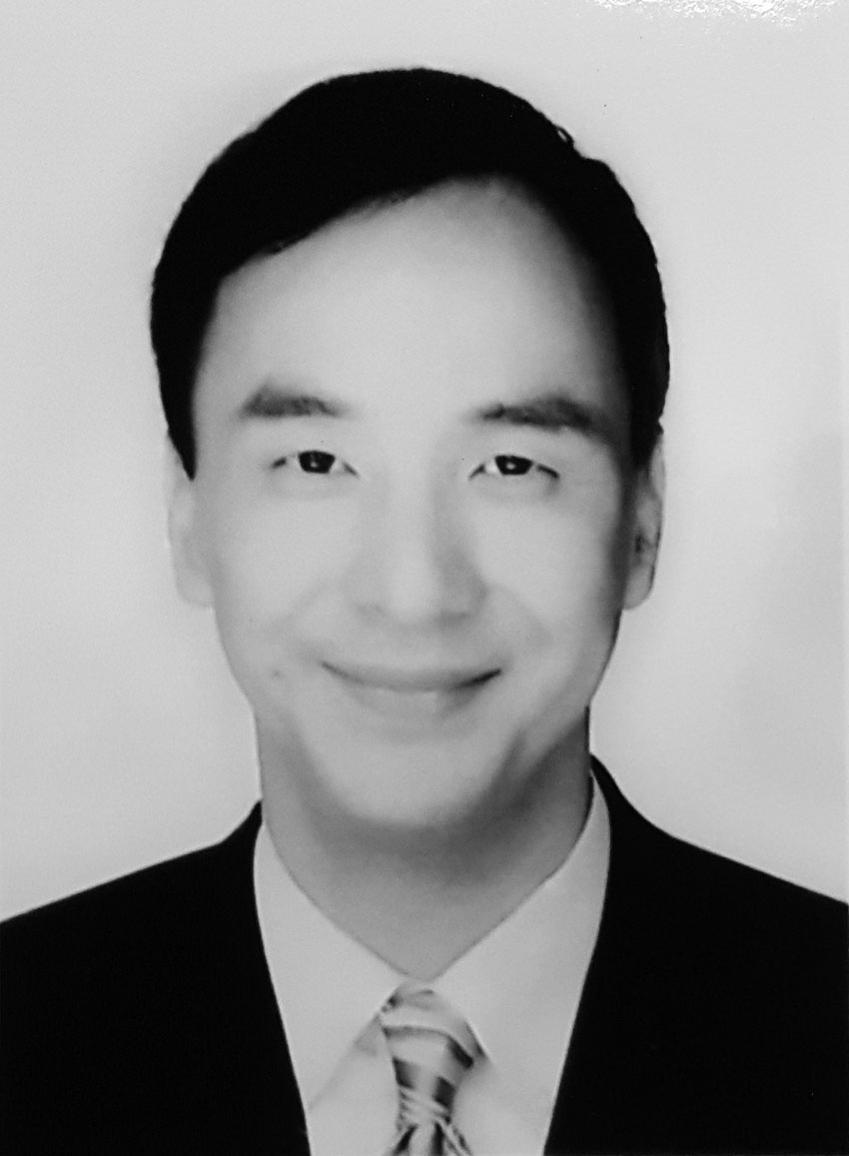
Dr. Eric Li-luan CHU
Date of Birth  Gender  Nomination | June 7, 1961  M  Recommended by Kuomintang (KMT)
Education
- Ph. D. in Accounting, New York University, USA
- MBA in Finance, New York University, USA
- BA in Management, National Taiwan University, ROC (Taiwan)
Career
- Chairperson,KMT
- Mayor, New Taipei City (2010-Present)
- Vice Premier(2009-2010)
- Magistrate, Taoyuan County(2001-2009)
- Legislator, Legislative Yuan (1998-2001)
- Professor, National Taiwan University
- Assistant Professor, Baruch College, City University of New York, USA

Running Mate
Ms. WANGJu-hsuan
Date of Birth  Gender  Nomination | October 2, 1961  F  Recommended by Kuomintang (KMT)
Education
- Master of Laws, Fu Jen Catholic University, ROC (Taiwan)
- Bachelor of Laws, National Taiwan University, ROC (Taiwan)

Career
- Minister, Council of Labor Affairs, Executive Yuan (2008-2012)
- President, Sunshine Education and Culture Association Taiwan
- Mayoral Advisor& Municipal Advisor, Taipei City Government
- Executive Director, Taipei Bar Association
- Managing Director, Modern Women’s Foundation

Presidential Candidate
Dr. TSAI Ing-Wen
Date of Birth  Gender  Nomination | August 31, 1956  F  Recommended by Democratic Progressive Party of Taiwan (DPP)
Education
- Ph. D., London School of Economics and Political Science, UK
- Bachelor of Laws, National Taiwan University, ROC (Taiwan)

Career
- Chairperson, DPP
- Vice Premier(2006-2007)
- Legislator at-large ofDPP
- Senior Advisor to the President
- Minister, Mainland Affairs Council, Executive Yuan
- Senior Advisor, National Security Council
- Member, Fair Trade Commission, Executive Yuan,
- Member, Mainland Affairs Council, Executive Yuan
- Chief Legal Advisor on International Economic Organizations, Ministry of Economic Affairs
- Professor, Soochow University
- Professor, National Cheng-Chi University

Running Mate
Dr. CHEN Chien-jen
Date of Birth  Gender  Nomination | June 6, 1951  M  Recommended by Democratic Progressive Party of Taiwan (DPP)
Education
- Sc.D. in Epidemiology and Human Genetics, John Hopkins University, USA
- Master of Public Health, National Taiwan University, ROC (Taiwan)

Career
- Vice President, Academia Sinica
- Distinguished Research Fellow, Genomics Research Center, Academia Sinica
- Minister, National Science Council, Executive Yuan
- Minister, Department of Health, Executive Yuan
- Vice Minister, National Science Council, Executive Yuan
- Dean, College of Public Health, National Taiwan University
- Director General, Division of Life Sciences, National Science Council, Executive Yuan
- Founding Director, Graduate Institute of Epidemiology, NationalTaiwan University
- Professor, National Taiwan University
Presidential Candidate
Dr. SOONG Chu-yu
Date of Birth  Gender  Nomination | March 16, 1942  M  Recommended by People First Party (PFP)
Education
- Ph. D. in Political Science, Georgetown University, USA
- Master of Library Science, The Catholic University of America, USA
- Master of Arts in Political Science, University of California, Berkeley, USA
- BA in Diplomacy, National Cheng-Chi University, ROC (Taiwan)

Career
- 13th Presidential Candidate(2012)
- 11th Presidential Running Mate(2004)
- 10th Presidential Candidate (2000)
- Governor, Taiwan Province
- Chairperson, Taiwan Provincial Government
- Secretary General, Central Committee Kuomintang (KMT)
- Representative, Central Standing Committee, KMT
- Deputy Secretary-General, Central Committee, KMT
- Director, Cultural and Communications Committee, KMT
- Spokesperson &Director General, Government Information Office, Executive Yuan
- Secretary to the President
- Deputy Director General, Government Information Office, Executive Yuan
- Adjunct Associate Professor, National Taiwan Normal University
- Adjunct Associate Professor, National Taiwan University
- Secretary of Premier Minister
- Adjunct Researcher, International Relations Research Center, National Cheng-Chi University

Running Mate
Dr. HSU Hsin-ying
Date of Birth  Gender  Nomination | April 23, 1972  F  Recommended by People First Party (PFP)
Education
- Ph.D. in Civil Engineering, National Chiao Tung University, ROC (Taiwan)
- Master of Science in Civil Engineering, National Chiao Tung University,ROC (Taiwan)
- Bachelor of Science in Geomatics, National Cheng Kung University, ROC (Taiwan)
Career
- Chairperson,Minkuotang (MKT)
- Legislator, Legislative Yuan (2012-2016)
- Professional Surveyor,ROC (Taiwan)
- Advisor, Taiwan Federation of Labor
- Adviser, Hsinchu Confederation of Trade Unions
- Advisor, Hsinchu Women’s Labor Rights Committee
- Advisor, Taiwan Association of Medical Technologists
- Advisor, Chunghwa Postal Workers’ Union, ROC (Taiwan)
- Advisor, Hsinchu County Educational Association
- Advisor, Global Hsu Clan Association, ROC (Taiwan)
- Advisor, Committee of Promoting Healthy City, Hsinchu County Government
- Consultant of Joint Briefing, Department of Transportation, Hsinchu County Government
- Advisor, Youth Care Association of Hsinchu County
- Organizer for Petition, Hsinchu County Council
- Councillor, Hsinchu County Council( 2006-2010)
- Councillor, Hsinchu County Council(2010-2014)
- Lecturer, Minghsin University of Science and Technology
- Researcher, Satellite Survey Center, Department of LandAdministration, Ministry of Interior
- Technical Expert, Big Time Measurement Consultants Ltd., ROC (Taiwan)

