DEMOCRATIC REPUBLIC OF SÃO TOMÉ E PRINCIPE
MINISTRY OF HEALTH

STAKEHOLDER ENGAGEMENT PLAN (SEP)

COVID-19 EMERGENCY RESPONSE PROJECT

INCLUDING ADDITIONAL FINANCE 2

2 MarCH 2021

Table of Contents
1. INTRODUCTION AND BACKGROUND 3
2. PROJECT DESCRIPTION 4
3. PURPOSE AND OBJECTIVE OF THE STAKEHOLDERS ENGAGEMENT PLAN (SEP) 7
4. LEGISLATIVE AND ENVIRONMENTAL AND SOCIAL STANDARDS REQUIREMENTS 8
4. STAKEHOLDER IDENTIFICATION AND ANALYSIS 8
4.1 Methodology 8
4.2. Affected parties 9
4.3. Other interested parties 10
4.4. Disadvantaged / vulnerable individuals or groups 10
5. STAKEHOLDER ENGAGEMENT PROGRAM 11
5.1. Stakeholders Consultation during Preparation 11
5.2. Disadvantaged and Vulnerable groups Engagement 12
5.3. Summary of project stakeholder needs and methods, tools and techniques for stakeholder engagement 12
5.4. Proposed strategy for information disclosure and consultation process 16
5.5. Proposed strategy for consultation 20
5.6: Learning and Feedback 22
5.7 Future of the project 22
6. RESOURCES AND RESPONSIBILITIES FOR IMPLEMENTING STAKEHOLDER ENGAGEMENT ACTIVITIES 23
6.1. Resources 23
6.2. Management functions and responsibilities 26
7. GRIEVANCE MECHANISM 26
7.1. Description of GRM 26
7.2 Venues to register Grievances - Uptake Channels 28
7.3 Grievances Relating to Gender-Based Violence (GBV) 28
7.4 COVID-19 Vaccination adverse events following immunization 28
8. MONITORING AND REPORTING 29
8.1. Involvement of stakeholders in monitoring activities 29
8.2. Reporting back to stakeholder groups 29
8.3. Monitoringindicators and targets 30
ANNEX I: PUBLIC CONSULTATION MINUTES 31

1. INTRODUCTION AND BACKGROUND
After the emergence of the new coronavirus, called COVID-19, in China and its spread outside China, on January 30, 2020, the Director-General of the World Health Organization (WHO) declared COVID-19 as a public health emergency of international concern (PHEIC), based on the opinion of the International Emergency Committee and within the framework of the International Health Regulations (2005). This Declaration implies that all countries must increase their preparedness for detection and containment of cases, including active surveillance, early detection, isolation and case management, follow-up contacts and prevention of the spread of COVID Disease 19. The proposed project aims to reinforce and maintain the country capacity to: (i) limit the transmission of COVID 19 in the population including health workers, (ii) strengthen early detection notification and confirmation of cases of COVID-19, (iii) effectively manage isolation and case management for all suspected and confirmed cases of COVID-19, (iv) support health promotion and community mobilization for the protection and prevention to COVID-19, and (v) reinforce the multisector coordination of partners to improve preparedness and response and to minimize the socio-economic impact of a potential outbreak of COVID-19.

The São Tomé e Príncipe (STP) COVID-19 Emergency Response Project (P173783) prepared under the Fast Track COVID-19 Facility (FTCF) was approved on April 2, 2020 and became effective on April 6, 2020.

The Republic of STP, with 1,054 COVID-19 confirmed cases as of January 8, 2020, shows one of the highest attack rates (441/100,000 people) in the region and still has limited capacity to handle the COVID-19 outbreak in the country.Located in the Gulf of Guinea, STP is a small low-middle-income country comprised of two main islands that was ill prepared to handle a pandemic such as the COVID-19. With an overall Global Health Security Index score of 17.7 (192/195 countries) and a recent Joint External Evaluation (JEE) assessment showing significant fragilities in terms of public health emergency preparedness and response, COVID-19 has been particularly difficult to manage in country. STP was unable to quickly establish laboratory capacity to diagnose COVID-19 due to the interruption of commercial flights to the island in the begging of the Pandemic. After several months without having laboratory capacity to diagnose COVID-19, early efforts to contain local transmission (first case diagnosed in early April) were hindered by incapacity to confirm diagnosis and isolate cases, perform contact tracing and slow transmission. This capacity was finally established in July, alongside with improved hospital capacity to manage cases and trained surveillance teams to perform contact tracing. Notwithstanding the fact that STP is now better prepared to diagnose, isolate, treat and track COVID-19 contacts, the capacity in country is still limited and a significant and more comprehensive strategy to use COVID-19 to strengthen public health systems will be key in ensuring that COVID-19 and future epidemics will be properly managed. As highlighted by WHO, the investments and expenditures for COVID-19 should also lead to longer-term, wider benefits, in line with national needs for sustainable capacities.

The STP COVID-19 Emergency Response Project (P173783), the parent project, is progressing well. The project development objective (PDO) of the parent project is to prevent, detect and respond to the threat posed by COVID-19 and strengthen national systems for public health preparedness. Both the PDO and overall implementation are both rated as satisfactory. As of January 2021, the overall disbursement rate of the STP COVID-19 Emergency Response Project stands at 69% (US$1.85 million) with the project being on track to fully disburse by March 31, 2021 as all the available funds are 100% committed to the procurement of COVID-19 related medical equipment and materials. The Project has been able to benefit from World Bank Facilitated Procurement (BFP) having entered into contracts with General Electric, Siemens, MEHECO, Commander, and the World Food Program (WFP) for the purchase and transportation of COVID-19 equipment and materials. The BFP contracts together add up to US$1.2 million with first payments having been made under each BFP contract which represent 37 percent of the total contract value. In addition to BFP, the project has finalized a Memorandum of Understanding (MOU) with WHO in the amount of US$1.3 million for technical assistance and implementation support in the installation and operationalization of the public health emergency operations center, reinforcement of the surveillance system, strengthening human resources for health capacity for the national laboratory diagnostic capacity, and the development of a national risk communication strategy. Specifically, the parent project has supported (i) the procurement of Personal Protective Equipment (PPEs) for surveillance teams at points of entry (including ports and airports), for healthcare workers, and laboratory technicians; (ii) procurement of laboratory equipment, reagents and commodities, and diagnostic equipment; (iii) the provision of durable medical equipment, surgical instruments, and other life-support equipment. Therefore, continuing Bank engagement is essential to enable a sustained and comprehensive pandemic response in São Tomé e Príncipe (STP). A first Additional Financing (P174880) of US$940,00 financed by the Pandemic Emergency Facility (PEF) is supporting this continued engagement and was approved on November 10, 2020. These PEF Trust Fund resources will be fully utilized by the January 31, 2021 closing date. The PEF resources are financing key emergency response activities including COVID-19 materials and equipment.

The epidemiological profile of Sao Tome and Principe continues to be dominated by communicable diseases with high incidences of acute respiratory diseases, diarrheal diseases, the persistence of some foci of neglected tropical diseases and other related diseases to the environment, the habits and behaviors of the populations. Non-communicable diseases (high blood pressure, diabetes and cancer) are increasing and represent today more than 60% of all health consultations.

A risk communication strategy is in place.Communication sessions with the general public on general measures for the prevention of acute respiratory diseases are carried out on television and radio, focus on frequent hand washing, respiratory etiquette, and maintaining distance and care in front of a person with symptoms of acute respiratory infection. The communication plan is being finalized.

2. PROJECT DESCRIPTION
Additional funding, the second AF, is being proposed for the project. This second AF is being proposed at a crucial moment in the Government's response to COVID-19. The second AF plays a critical role in allowing equitable access to vaccines and expanding project activities and strengthening the health system to achieve project development objectives (PDO) and increase project impact. The closure of the project, which was scheduled for June 30, 2022, will be extended to June 30, 2024. A two-year extension that will allow full use of the $6 million PA that is being introduced by the two funding sources: AID grant (US $ 3 million) and the Health Emergency Preparedness and Response Trust Fund (HEPR TF) (US $ 3 million).
The project's development objective (PDO) is to prevent, detect and respond to the threat posed by COVID-19 and to strengthen the national public health preparedness system in São Tomé and Príncipe. The overall objective of the project is to fill critical funding gaps in the National Action Plan for Health Security (PANSS) and to improve the capacity to comply with the International Health Regulations (IHR) in STP and, at the same time, strengthen the activities of preparation and response to the COVID-19 outbreak. The components of the project are shown in the table1.
The specific objectives of the project, aligned with the STP’s draft NAPHS andSão Tomé e Príncipe’s COVID-19 Plan are to: (i) strengthen coordination of preparedness and response operations at national and subnational levels; (ii) strengthen surveillance capacity for early detection of cases, alert/rumor management and contact tracing; (iii) strengthen nationwideIHR core laboratory capacitiesincluding the diagnosis of COVID-19; (iv) improve national strategy for risk communication and community engagement thus increasing awareness and informed decision-making among communities; (v)reinforce IHR core capacities at points of entry, including screening for COVID19 when applicable ; (vi) increase the capacity to rapidly isolate and provide optimized care for persons suspected or confirmed to have COVID-19; (vii) implement optimal infection and control measures in healthcare settings and communities; ; and (vii) provide and pre-position medical supplies and commodities, and other logistics for COVID-19 management.

The STP COVID-19 Emergency Response Projectcomprises the following components:

COMPONENT 1: Emergency COVID-19 Response (US$ 5 million made up of US$ 2.5 million IDA Grant plus US$2.5 million HERP TF). This component will continue to support, in line with the National COVID-19 Preparedness Plan, the improvement of COVID-19 laboratory diagnostics and treatment capabilities through provision of laboratory diagnostic tests and supplies, as well as, clinical management capacity across designated COVID-19 treatment centers. This second AF will enable STP to increase the number of available beds, continue to support equipping intensive care units and procuring medicines and consumables for COVID-19 designated hospitals. Additionally,this component will support the MOH to develop its national COVID-19 immunization plan and to ensure the necessary conditions to implement it: technical assistance to design the national COVID-19 immunization plan; procurement of COVID-19 vaccines, vaccination supplies, and PPE for vaccinators; logistics and cold chain; and support program delivery. More specifically, the second AF support under this component would follow the existing sub-components with the addition of a specific COVID-19 immunization sub-component (sub-component 1.4).

Sub-component 1.1 – Case Detection, Confirmation, Contact Tracing, Recording, Reporting (US$ 1 million made up of US$ 0.5 million IDA Grant plus US$ 0.5 million HERP TF). The second AF for this sub-component will allow the continued support for the operationalization of indicator-andevent-basedsurveillance to respond to COVID-19; establishing protocols, processes and regulations for reporting to WHO, OIE and FAO on public health emergencies, including regular reporting on COVID-19 epidemiology; implementation of International Health Regulations (IHR) core capacities and contingency plans for COVID-19 at Points of Entry (PoEs); strengthening Rapid Response Teams in country to respond to COVID-19; and strengthening the national laboratory diagnostic to conduct COVID-19 diagnostic tests as well as in the mid-term build capacity for key priority diseases in accordance to WHO guidance. All these activities have already begun to be implemented by the MOH with the support of WHO (through the US$1.3 million MoU signed using the COVID-19 parent project (P173783). Furthermore, it will provide the necessary financial support to ensure implementation of the Field Epidemiology Training Program (FETP) Frontline program in-country to provide epidemiology training and develop the public health workforce to better respond to emergencies, that had been postponed due to the lack of funding in the parent project. This sub-component will create the foundations of disease surveillance and emergency preparedness for health emergencies.

Sub-component 1.2 – Risk communication, community engagement and social distancing [US$ 1.25 million HERP TF]: Under this sub-component, this second AF will provide financing for COVID-19 Immunization planning, strengthening supply chain, and program delivery. Key activities to be financed include: (i) support government in developing the national deployment and vaccination plan and associated budget; (ii) support country in developing the legal regulatory documents and plans to ensure swift importation of the COVID-19 vaccine; (iii) strengthen national immunization budgeting and budget tracking capacity; (iv) support the estimation, mapping and identification of target populations; (v) support the development of vaccination micro-plans; (vi) support the development of a human resources (HR) mobilization and training plan for vaccine roll-out. Specifically, program delivery activities will include: (i) implement the national risk-communication, demand creation and community engagement plan for COVID-19; (ii) ensure vaccines reach the target populations; (iii) strengthen and adapt Pharmacovigilance System (PVS) to be sensitive to detect Adverse Events Following Vaccination (AEFI) for the COVID-19 vaccine; and (iv) ensure adequate waste management and ensure adequate financing of plans.

Sub-component 1.3 – Health systems capacity to respond to COVID-19 (US$ 1.25 million made up of US$ 0.75 million IDA Grant plus US$ 0.5 million HERP TF): This sub-component will continue supporting the following activities: establishment and upgrading of health care facilities to increase COVID-19 case management capacity; establishment and training of Emergency Medical Teams (EMTs) to respond to COVID-19 emergency; design of Infection Prevention and Control (IPC) procedures and protocols applied to COVID-19 and other epidemic prone diseases; ensuring water supply, sanitation and hygiene services and medical waste management in health care facilities; procurement of commodities for IPC precautions (personal protective equipment); ensuring essential health services continuity during the pandemic and other potential public health emergencies; continued implementation of plan to support critical functions that must continue during a widespread outbreak of COVID-19 (e.g., water and sanitation, fuel and energy, food, telecommunication/internet, finance, education, and transportation, necessary resources, and essential workforce); improvement of biosecurity in livestock production and trade, through the continued support for the implementation of a One Health Platform to ensure an integrated human-animal-environment health approach with the longer term vision of reducing health related risks throughout agriculture, food and environmental systems.

Sub-Component 1.4 - Procurement of COVID-19 vaccines and consumables(US$ 1.5 million made up of US$ 1.25 million IDA Grant plus US$ 0.25 million HERP TF). In light of the fact that the HEPR TF cannot be used to purchase vaccines, the purchase of the COVID-19 vaccines will be done through the IDA Grant while the procurement of consumables will be supported by both the HEPR TF and the IDA Grant under the COVID-19 SPRP. Under sub-component 1.4, the IDA Grant will finance the procurement of COVID-19 vaccines, including increased/equitable access to vaccines procured via the mechanism selected by the country (e.g., COVAX, other) and in accordance with criteria adopted under Global MPA AF. In addition to the vaccines, this subcomponent will also finance the procurement of ancillary supply kits that may include needles, syringes, alcohol prep pads, COVID-19 vaccination record cards for each vaccine recipient, and a minimal supply of personal protective equipment (PPE), including surgical masks and face shields, for vaccinators.

COMPONENT 2: Strengthening Multi-sector, National Institutions and Platforms for Policy Development and Coordination of Prevention and Preparedness including One Health approach (US$ 0.5 million made up of US$ 0.25 million IDA Grant plus US$0.25 million HERP TF). This component will continue supporting the implementation and sustainability of the Emergency Operations Centre (EOC) within MoH to manage the COVID-19 response and use the platform to design and create the Public Health Emergency Program for the country. Furthermore, this component will continue supporting investments in One Health.

COMPONENT 3: Project Management and Monitoring and Evaluation (M&E) (US$ 0.5 million made up of US$ 0.25 million IDA Grant plus US$ 0.25 million HERP TF). This component will continue to support the coordination and management of project activities, including procurement of goods and their distribution across health facilities within STP. Furthermore, this component will strengthen existing data and monitoring systems (immunization and public health) to accommodate for the COVID-19 vaccines and therefore improve data collection, analysis, reporting and use of data for action and decision-making. The existing project implementation unit (AFAP) will be responsible for overall administration, procurement, and financial management and M&E of project activities

Table 1. Activities by project component and respective budget by component
Components & Sub-Components | Total Second AF Costs | IDA Grant | HEPR TF
Component 1: Emergency COVID-19 Response | 5.00 | 2.50 | 2.50
Sub-Component 1.1: – Case Detection, Confirmation, Contact Tracing, Recording, Reporting | 1.00 | 0.50 | 0.50
Sub-Component 1.2: Risk communication, community engagement and social distancing | 1.25 | 0 | 1.25
Sub-Component 1.3: – Health systems capacity to respond to COVID19 | 1.25 | 0.75 | 0.50
Sub-Component 1.4: – Procurement of COVID-19 vaccines and consumables | 1.50 | 1.25 | 0.25
Component 2: Strengthening Multi-sector, National Institutions and Platforms for Policy Development and Coordination of Prevention and Preparedness including One Health approach | 0.50 | 0.25 | 0.25
Component 3: Project Management and Monitoring and Evaluation | 0.50 | 0.25 | 0.25
Total Project Cost | 6.00 | 3.00 | 3.00

3. PURPOSE AND OBJECTIVE OF THE STAKEHOLDERS ENGAGEMENT PLAN (SEP)
The WB ESS10 “Stakeholders engagement and information disclosure”requires that Borrowers engage with stakeholders throughout the project life cycle, commencing such engagement as early as possible in the project development process and in a timeframe that enables meaningful consultations with stakeholders on project design. The nature, scope and frequency of stakeholder engagement will be proportionate to the nature and scale of the project and its potential risks and impacts.
The objectives of this SEP:
- To establish a systematic approach to stakeholder engagement that will help STP Government identify stakeholders and build and maintain a constructive relationship with them, in particular project-affected parties.
- To assess the level of stakeholder interest and support for the project and to enable stakeholders’ views to be taken into account in project design and environmental and social performance.
- To promote and provide means for effective and inclusive engagement with project-affected parties throughout the project life cycle on issues that could potentially affect them.
- To ensure that appropriate project information on environmental and social risks and impacts is disclosed to stakeholders in a timely, understandable, accessible and appropriate manner and format.
- To provide project-affected parties with accessible and inclusive means to raise issues and grievances, and allow Borrowers to respond to and manage such grievances.

4. LEGISLATIVE AND ENVIRONMENTAL AND SOCIAL STANDARDS REQUIREMENTS
Under STP Legislation, stakeholders´ engagement is required during environmental and social impact assessment. According to decree 37/99 of 30th November, Regulation for Environmental Impact Assessment, public consultation process is a compulsory activity for all projects subjected to to Impact Assessment process. The public consultation process is fully described in Article 7 of the decree.

In order to carry out the public consultation during the EIA process the governmental entity responsible for the environment should adopt the methods which, on a case-by-case basis, are adequate for the achievement of the intended objectives, anticipating full access to all information.

ESS10 sets out that a Borrower has to engage with stakeholders as an integral part of a Project’s environmental and social assessment and project design and implementation. The nature, scope and frequency of the engagement should be proportional to the nature and scale of the Project. Consultations with stakeholders have to be meaningful and be based on stakeholder identification and analysis, plans on how to engage stakeholders, disclosure of information, actual consultations, as well as responses to stakeholder grievances, and reporting back to stakeholders.

4. STAKEHOLDER IDENTIFICATION AND ANALYSIS
The nature of COVID-19 makes everyone an important stakeholder in the project, either to prevent the virus from spreading in the country or minimizing a risk of infecting others if one becomes infected. Cooperation and negotiation with the stakeholders throughout the Project development often also requires the identification of persons within the groups who act as legitimate representatives of their respective stakeholder group, i.e., the individuals who have been entrusted by their fellow group members with advocating the groups’ interests in the process of engagement with the Project. Community representatives may provide helpful insight into the local settings and act as main conduits for dissemination of Project-related information and as a primary communication/liaison link between the Project and targeted communities and their established networks. Verification of stakeholder representatives (i.e., the process of confirming that they are legitimate and genuine advocates of the community they represent) remains an important task in establishing contact with the community stakeholders. Legitimacy of the community representatives can be verified by talking informally to a random sample of community members and heeding their views on who can be representing their interests in the most effective way.

Project stakeholders are defined as individuals, groups or other entities who:
- are impacted or likely to be impacted directly or indirectly, positively or adversely, by the Project (also known as ‘affected parties’); and
- may have an interest in the Project (‘interested parties’). They include individuals or groups whose interests may be affected by the Project and who have the potential to influence Project outcomes.

4.1 Methodology
In order to meet best practice approaches, the project will apply the following principles for stakeholder engagement:
- Openness and life-cycle approach: public consultations for the project(s) will be arranged during the whole life-cycle, carried out in an open manner, free of external manipulation, interference, coercion or intimidation. Due to the nature of the project which everyone in the country has got interest in this topic, mass means of communication should be considered (TV, Radios, Newspapers, banners, sms, telephone lines, e-mails and public audiences)
- Informed participation and feedback: information will be provided to and widely distributed among all stakeholders in an appropriate format; opportunities are provided for communicating stakeholders’ feedback, for analyzing and addressing comments and concerns;
- Inclusiveness and sensitivity: stakeholder identification is undertaken to support better communications and build effective relationships. The participation process for the projects is inclusive. All stakeholders are encouraged to be involved in the consultation process. Equal access to information is provided to all stakeholders. Sensitivity to stakeholders’ needs is the key principle underlying the selection of engagement methods. Special attention is to be given to vulnerable groups – in particular, women, persons with disabilities, youth, the elderly, and those with chronic illnesses.

For the purposes of effective and tailored engagement, stakeholders of the proposed project can be divided into the following core categories:
- Affected Parties – persons, groups and other entities within the Project Area of Influence (PAI) that are directly influenced (actually or potentially) by the project and/or have been identified as most susceptible to change associated with the project, and who need to be closely engaged in identifying impacts and their significance, as well as in decision-making on mitigation and management measures;
- Other Interested Parties – individuals/groups/entities that may not experience direct impacts from the Project but who consider or perceive their interests as being affected by the project and/or who could affect the project and the process of its implementation in some way; and
- Vulnerable Groups – persons who may be disproportionately impacted or further disadvantaged by the project(s) as compared with any other groups due to their vulnerable status, and that may require special engagement efforts to ensure their equal representation in the consultation and decision-making process associated with the project.

4.2. Affected parties
Although the nature of the diseases and its impacts makes everybody affected, either direct or indirectly, for the purpose of this SEP we will consider Affected Parties individuals, groups, and communities directly affected by project interventions and other parties that may be subject to direct impacts from the Project. Specifically, the following individuals and groups fall within this category:
- COVID-19 infected peopleas a result of the project or using project facilities or services
- Vaccine recipient
- Vulnerable groups target of vaccination (elderly and chronically ill)
- People under COVID-19 quarantine, including workers in the quarantine facilities
- Hospital patients
- Relatives of COVID-19 infected people
- Relatives of people under COVID-19 quarantine
- Neighboring communities to laboratories, quarantine centers, and screening posts
- Workers at construction sites of laboratories, quarantine centers and screening posts
- Public health workers
- Health workers in contact with or handlingmedical waste
- Municipal waste collection and disposal workers
- Ministry of Health officials
- People and businesses affected by or otherwise involved in project-supported activities
- District Municipal workers responsible for waste management public spaces, market and general city clearing(Água Grande, Me-zoche, Lobata, Lembá, Canta Galo, Caué e Região Autónoma de Príncipe (RAP)
- Public Works servants that have to attend several people
Staff responsible for handling supplies at air or sea ports
- Workers of large public places, including public markets, supermarkets, schools, police, etc.;
- Transportation companies’ staff providing both international and domestic freight or passengers transportation.

4.3. Other interested parties
The projects’ stakeholders also include parties other than the directly affected people, including:
- Traditional media: Capital, Jornal de São Tomé, Jornal Tropical, Diário Vitrina, Jornal Transparência ST, Agência STP-Press, O Parvo, TVSão Tomé, RDP Africa, RTP internacional, Radio Nacional de STP, Voz da América.
- Politicians: Movimento de Libertação de São Tomé e Príncipe, Acção Democrática Independente (ADI), Partido Social Democrata (MLSTP-PSD), Partido de Convergência Democrática/Grupo de Reflexão (PCD/GR), União dos Democratas para Cidadania e Desenvolvimento da Mudança (UDD), MDFM,
- National and international health organizations: World Health Organizations,
- National andInternational NGOs and Associations in Health sector;National Association of Nurse Midwives (ANEP); National Union of Nurses and Midwives (SINEP); FONG; Ordem dos médicos, Associaçao dos médicos, Sindicato dos enfermeiros,
- Public and private Logistic companies that must import covid-19 vaccines and other related consumables

4.4. Disadvantaged / vulnerable individuals or groups
It is particularly important to understand whether project impacts may disproportionately fall on disadvantaged or vulnerable individuals or groups, who often do not have a voice to express their concerns or understand the impacts of a project and to ensure that awareness raising and stakeholder engagement with disadvantaged or vulnerable individuals or groups [on infectious diseases and related medical treatments] be adapted to take into account the needs of such groups or individuals, their concerns and cultural sensitivities, and to ensure a full understanding of project activities and benefits.The vulnerability may stem from person’s origin, gender, age, health condition, economic status and financial situation, disadvantaged status in the community (e.g., minorities or fringe groups), or dependence on other individuals and/or the state. Engagement with vulnerable groups and individuals often requires the application of specific measures and assistance aimed at the facilitation of their participation in project-related decision-making so that their awareness of and input to the overall process are commensurate to those of other stakeholders.

Within the Project, the vulnerable or disadvantaged groups may include and are not limited to the following:

- Elderly
- Illiterate people
- Ethnic or religious minorities
- People with disabilities, Blind and partially sighted Association (ACASTEP), Association of prostate patients São Tomense, Association of Physically Disabled
- People living in remote or inaccessible areas
- Female-headed households
- Patients with chronic illnesses
- Daily wage earners,
- Those living below the poverty line,
- Unemployed

Vulnerable groups affected by the project will be further confirmed and consulted during project implementation. Description of the methods of engagement that will be undertaken by the project is provided in the following sections.

5. STAKEHOLDER ENGAGEMENT PROGRAM

5.1. Stakeholders Consultation during Preparation
In order to incorporate stakeholders´ views and concerns about the project a public consultation meeting was held on 27th June 2020 where ESMF, LMP, ICPWM and SEP were presented to the public. Due to the limitations imposed by COVID-19, a virtual meeting was held, supplemented by a physicalmeeting respecting physical distancing imposed by health authorities. A Zoom platform was used for virtual meeting. The stakeholders that attended the meeting are: Representatives of the Ministry of Health of São Tomé and Príncipe; Representatives of the Fiduciary Agency for Project Management (AFAP); Representatives of the São Tomé and Príncipe District Chambers; Representatives of the General Directorate for the Environment of São Tomé and Príncipe; Representative of the Ministry of Agriculture; Representatives of the Blind and partially sighted Association (ACASTEP); Representatives of the National Association of Nurse Midwives (ANEP); Representatives of the National Union of Nurses and Midwives (SINEP); and community members in general. See attendance sheet and a full consultation report in Annex 1. Issues raised during the consultation meeting with stakeholders included:
- A need to include a food security component into the project, to ensure there is enough food for the vulnerable in São Tomé and Príncipe amid the pandemic. Also because food is essential to strengthen immunity.
- A need to ensure that project benefits forordinary people, and to identify objective criteria for selection of activities to be financed by the project by assessing the positive impact on the community in general.
- The final destination of waste generated in COVID treatment installation, giving an example of the tent.
- A need for the project to consider buying agricultural surpluses from small farmers who have not found a market in this pandemic moment, suggesting that these products could be used to feed COVID-19 patients.
- A need to develop activities to provide food for disabled people during pandemic, since there is movement limitation imposed by the authorities.
- Lack of protective equipment (masks, gloves, etc.) in hospitals, which puts health professionals exposed to infection with the new coronavirus
More consultation will be doneduring the project implementation in order to allow stakeholders views to be continuously taken into consideration.
The parent project is now several months into implementation, so some of the actions that were planned in the parent project documents in terms of SEP where done, including disclosure of SEP, ESCP, ESMF and ICWMP.

5.2. Disadvantaged and Vulnerable groups Engagement
Engagement of Vulnerable groups is always a challenge due to various limitations they face. In STP Disadvantaged and / or vulnerable groups are being registered through several initiatives (such as poverty survey), an ongoing survey by the social security sector (Direcção de Protecção Social e Família – DPSF) and other initiatives, through which subsidies and assistance are channeled to the vulnerable. On the other side most of the vulnerable, specially the disabled are members of different associations where they seek for assistance or they make they voice their concerns, as listed in previous sections.
The above-mentioned institutions and channels used by them to reach to vulnerable groups will be used in this program to reach to those families and distribute relevant information based on stakeholders needs information presented in Table 2.

5.3. Summary of project stakeholder needs and methods, tools and techniques for stakeholder engagement
The WHO “COVID-19 Strategic Preparedness and Response Plan -- Operational Planning Guidelines to Support Country Preparedness and Response--” (2020) outlines the following approach in Pillar 2 Risk Communication and Community Engagement, which will be the basis for the Project’s stakeholder engagement:
It is critical to communicate to the public what is known about COVID‑19, what is unknown, what is being done, and actions to be taken on a regular basis. Preparedness and response activities should be conducted in a participatorymanner, and be informed by and continually optimized according to community feedback to detect and respond to concerns, rumours and misinformation. Changes in preparedness and response interventions should be announced and explained ahead of time and be developed based on community perspectives. Responsive, empathic, transparent and consistent messaging in local languages through trusted channels of communication, using community-based networks and key influencers and building capacity of local entities, is essential to establish authority and trust.
Table 2 outlines methods to be employed for stakeholder engagement activities including consultations and information dissemination. The methods vary according to the characteristics and needs of stakeholders, and will be adapted according to circumstances related to the COVID-19 public health emergency.

Table 2: Stakeholders needs Matrix
Target stakeholders | Key Characteristics | Specific Needs ((accessibility, large print, child care, daytime meetings etc.) | Language needs | Position with regards to the project (support, neutral, opposition) | Preferred notification means  (email, radio,  phone, letter) | Level of (High, medium, low)  influence | Appropriate engagement approach
Government Ministries and Health Authorities  International Organizations  Local NGOs, religious leaders  Other Institutional Stakeholders, comunicação social | Literate  Literate  Literate  Literate | None | Portuguese | Support  Support  Support  Support | e-mail, newspaper,  Radio, TV,  Website, outdoor,  Virtual meetings,  Workshops (where feasible) | High | E-mail correspondence, videoconference meetings,  Interviews with Public Health Experts, Virtual consultation meetings, surveys, sms, whatsup, telephone calls, mails, Television
COVID-19 Infected People  Vaccine reccipients  People in Quarantine  Other Hospital Patients | Literate  /not Literate | Information accessibility | Portuguêse, santome, lung'Ie angolar e o kabuverdianu | Support | Radio, TV, phone, outdoor,  folhetos | Low | Press releases,  Information leaflets, Radio, television, newspaper and social media announcements, sms, whatsup, outdoors, booklets, handouts, using actors on TV and radio  Toll-free hotline for information dissemination and grievance uptake
Health Sector Workers  Project Workers | Literate | None | Portuguese | Support | e-mail, newspaper,  Radio, TV,  Website, outdoor,  Virtual meetings,  Workshops (where feasible) | High | E-mail correspondence, videoconference meetings,  Interviews with Public Health Experts, Virtual consultation meetings, surveys, SMS, whatsapp, telephone calls, mails
Vulnerable Individuals and Groups (women, children, old people, Disabled people)  Vulnerable groups target of vaccination program (elderly, chronically ill,…) | Not literate | Specific messages/awareness targeting women/girls will also be educated on risks and safeguard measures to prevent GBV/SEA in quarantine facilities, managing increased burden of care work and also as female hospital workers. | Portuguese santome, lung'Ie angolar e o kabuverdianu | Support | Radio, TV, phone, outdoor,  Liflets, meetings (where feasible), Virtual consultation meetings, surveys, sms, WhatsApp, telephone calls, mails | Low | Limited consultation meetings (where feasible), radio, TV, SMS, outdoors,

5.4. Proposed strategy for information disclosure and consultation process
Stakeholder engagement activities should be inclusive and carried out in a culturally-sensitive manner, and care must be taken to ensure that the vulnerable groups identified above will have opportunities to be included in consultations and project benefits. Methods typically include household-outreach and focus-group discussions in addition to community public consultation meetings, and where appropriate verbal communication or pictures should be used instead of text. The project will have to adapt to different requirements. While country-wide awareness campaigns will be established, specific communication around ports of entry and airports as well as quarantine centres and laboratories will have to be timed according to need and adjusted to local circumstances.
Given the current context resulting from recent measures put in place to address the pandemic and the timeline in which the project is being prepared, there are limited opportunities available to engage and consult with stakeholders during project preparation. Restrictions on social gatherings, which limit face-to-face social interactions, will constrain the project’s stakeholder engagement processes and require the implementation of innovative communication and consultation methods. Given the wide range of stakeholders (potentially affected people and other interested parties) in this project, a robust stakeholder engagement and communication strategy will need to be developed; the project component on “Risk Communication and Community Engagement” (RCCE), encompassing behavioural and sociocultural risk factors assessment, production of RCCE strategy and training documents, production of communication materials, media and community engagement, and documentation in line with WHO “Pillar 2: Risk communication and community engagement” will be implemented to address this.
As indicated above, it may be necessary to:
- Diversify means of communication and rely more on social media and online channels. Where possible and appropriate, create dedicated online platforms and chat groups appropriate for the purpose, based on the type and category of stakeholders;
- Employ traditional channels of communications (TV, newspaper, radio, dedicated phone-lines, public announcements and mail) when stakeholders do not have access to online channels or do not use them frequently. Such channels can also be highly effective in conveying relevant information to stakeholders, and allow them to provide their feedback and suggestions;
- Employ online communication tools to design virtual workshops in situations where large meetings and workshops are essential, given the preparatory stage of the project. Webex, Skype, and in low ICT capacity situations, audio meetings, can be effective tools to design virtual workshops. The format of such workshops could include the following steps:
  - Virtual registration of participants: Participants can register online through a dedicated platform.
  - Distribution of workshop materials to participants, including agenda, project documents, presentations, questionnaires and discussion topics: These can be distributed online to participants.
  - Review of distributed information materials: Participants are given a scheduled duration for this, prior to scheduling a discussion on the information provided.
  - Discussion, feedback collection and sharing:
    - Participants can be organized and assigned to different topic groups, teams or virtual “tables” provided they agree to this.
    - Group, team and table discussions can be organized through social media means, such as webex, skype or zoom, or through written feedback in the form of an electronic questionnaire or feedback forms that can be emailed back.
  - Conclusion and summary: The chair of the workshop will summarize the virtual workshop discussion, formulate conclusions and share electronically with all participants.

In situations where online interaction is challenging, information can be disseminated through digital platform (where available) like Facebook, Twitter, WhatsApp groups, Project websites, and traditional means of communications (TV, newspaper, radio, phone calls and mail with clear description of mechanisms for providing feedback via mail and / or dedicated telephone lines. All channels of communication need to clearly specify how stakeholders can provide their feedback and suggestions.
In general, after engagement with stakeholders at list a period of 7 days should be provided to allow stakeholders to raise and send their comments through the channels provided during the engagement.
The specific needs for each stakeholders group will be discussed in every consultation meeting, and the list below will be updated throughout the project. Data related to stakeholder needs will be inserted in table below.

Communication Strategies for COVID-19 Vaccination Program
A strategic communication plan for the Extended Vaccination Program (EVP) 2020-2025 has been approved, the plan aims to improve people's support for different immunization interventions, making them sustainable through training programs for EVP managers, immunization actors, community involvement and media professionals at all stages of planning implementation, monitoring and evaluation.
Social Mobilization
It will identify and mobilize inter-sectorial allies and partners to identify the real needs of communities with their own communities, build knowledge and increase the search for specific objectives of co-ordinate with the EIPP. The main partners will be:
- Basic Community Organizations,
- Associations
- Artists
- Practitioners.
- Religious (Pastors, Priests)
- Teachers...
- Coordinating Committee
- Political and traditional leaders
- Community Leaders
- NGOs and other partners
- Communication for Behavioral Change (CCC)

This strategy aims to maintain and reinforce the desired action in an individual or group, and is the essential support to support activities to combat diseases preventable by vaccination. It thus contributes to improving the level of knowledge of populations, local elected officials, heads of opinion and socio-health staff, diseases and their care, in order to obtain their support without which lasting action cannot be taken.
Various communication channels are used: public, radio, national television and local radio stations, banners, and others
Priority goals
Priority objectives are defined in the vaccination target group, including:
- Health professionals,
- Social workers
- Elderly
- chronically ill, disabled
- Military
- Paramilitary
- General public

The activities will be developed based on awareness and communication objectives for a wide coverage among populations and communities.
The following activities will be implemented:
- Organize awareness and advocacy sessions with political and administrative authorities to support the Covid-19 vaccine
- Develop an appropriate communication plan for the community
- Educate doctors about the introduction of the Covid-19 vaccine
- Develop educational messages and materials about Covid-19;
- Reproduce and distribute educational materials on Covid-19;
- Organize awareness-raising days for media professionals, NGOs and others
- Organize the official launch for the introduction of the Covid-19 vaccine
- Organize interpersonal communication activities
- Identification and Management of Rumors, information and e-mail movements against vaccination or that may alter the results of vaccination.

The program will work together with the CNES for the development and implementation of the communication plan, including crisis communication in case of rumors about the Covid-19 vaccine in the country.
The project includes considerable resources to implement the above actions under Component 1, subcomponent 1.2. The table below briefly describes what kind of information are being/will be disclosed, in what formats, and the types of methods that are used to communicate this information at four levels to target the wide range of stakeholder groups and the timetables

Table 3. Proposed Information Disclosure Methods during Implementation Stage
Level | Information to be  disclosed | Proposed methods | Timelines/ Locations | Target stakeholders | Coverage | Responsibilities
National level | Prevention tips and Covid-19 symptoms | Audio and Video clips | National radio and TV | Adults, adolescents, children | 45% of population | MoH
 | New types of information materials (psychological support) | Printed booklets, outdoors | National wide | Schools | 15% | MES school departments
 | New types of information materials (psychological support) | Information & educational materials | Social media platforms | Internet users, youth | 20% of population | PIU community outreach  specialist,  communications  specialist in social and behavioural change
 | Hotline | Phone consultations | 24/7 MOH  Information  Center | Public at large | TBC | Health professionals
National and local | E&S  instruments: updated ESMF,  site-specific  ESMPs,  ICWMPs,  GRM, LMP | Website disclosure, site-specific ESF tools printed and available at the HCF level | As soon as they approved; Before any civil works start | Public at large, targeted HCF staff and surrounding communities | <50% | PIU  Environmental and Social Specialists
level
National level | Information materials on vaccination (posters) | Printed materials, training materials | February/March 2021 | health workers, educators, vulnerable groups aged above 50 years old/elderly and chronically ill people | 20% | MOH;  PAV; PIU communication  specialist in social and behavioural changes
National level | Information material on vaccine distribution plan | Printed materials, Mass media. Megaphones | February/March 2021 | health workers, educators, vulnerable groups aged above 60, chronically ill people | 80% | MOH;  PAV; PIU communication  specialist in social and behavioural changes
National Level | COVID-19 Vaccine hesitancy and any cultural barriers to access and participation in engagement and in vaccination. | National and community radio and TV, sms, audio clips - on Benefits of vaccination; positive feedback on vaccination process, raise awareness and trust | March 2021- on going | Churches and religious leaders, Community leaders, vaccination target people/vulnerable groups, public at large | 80% | MOH;  PAV; PIU communication  specialist in social and behavioural changes
National Level | Communication and engagement around not implementing forced COVID-19 vaccination | Clear policy statement and communication to health workers and any other involved in vaccination program | March 2021 | health workers and any other workers or servants involved in vaccination program | TBC | MoH
National level | Development  and distribution of video clips, TV and Radio programs, sms, | Video materials, disks | January-  February 2021 | Wide range of population | 30% | MoH

5.5. Proposed strategy for consultation
The following methods will be used during the project implementation to consult with key stakeholder groups, considering the needs of the final beneficiaries, and in particular vulnerable groups. Proposed methods vary according to target audience as showed in Table 4.

Table 4. Proposed Stakeholder Consultation Methods during Implementation Stage
Level | Subject | Method | Timeframes | Target stakeholders | Responsibilities
Country-wide | Communication  Strategy  Development | Interviews / phones/ SMS/ emails | Feb/March 2021 | Journalists, CSOs leaders, educators and health workers | UNICEF, WHO,  MOH, PIU  Communication  Specialist
National | Provision of emergency social assistance to poor households to improve nutrition | SMS,  advertisements in the communities, localchurches and community-based organizations | Regularly | Poor households with low income, children with disabilities,  female-headed families, unemployed, chronically ill people, elderlies … | Social Affairs Services, PIU,NGOS, Community based organizations
National | Data collection on received complaints, GRM | Phone interviews, phone complaints, written request, website, Internet, direct complaints in COVID-19 treatment centres and the vaccination centres | Regularly | Heads of the hospitals/Health centres, Social Protection sector, Heads of the hotlines, NGOs, Community based Organizations | PIU Social  Issues  Specialist
National | Hotline improvement at  MOH | Discussions with line ministries, administrators and users | Following recommendations on  Hotline assessment | Hotline  administrators and users | PIU/MoH  Social  Specialist
Country-wide | Project accomplishments | Multiple channels (TV, newspaper, surveys, meetings,…) | Constantly | Public at large | PIU/MOH  Social  Specialist
National | National Deployment and Vaccination  Plan | Will be disclosed at the website, coverage at the national TV, radio and print media | Regularly | Public at large | MOH/ Press  Center /sms
National | Creation and maintenance of website ,  YouTube channel,  Facebook and  Instagram page | Discussions | constantly | Republic Center of  Formation of  Healthy Lifestyle | PIU  Communication  Specialist/behavioural l change
National | Medical supply and equipment installation and vaccination centres mapping | Discussions | Jan - February 2021 | Other donors and MOH officials | PIU Management
Regional | WHO protocols and recommendations  on COVID-19  treatmentand COVID-19 vaccination | Practical training, which include a module on the importance of beneficiary feedback from patients | Regularly | Doctors,  Nurses | MOHSP  specialists,  WHO technical assistance
Regional and  District | Rehabilitation works, reequipment to organize Intensive  Care Units | Consultation with communities | Jun2020 -March 2021 | Communities  nearby the civil works site | PIU  Environmental and Social Issues  Specialist
District | Infection Control and Waste Management plans, ESMPs | Meetings, site visits,  community  consultations | Before bidding for construction | Local  community and HCF health workers, waste management workers | PIU  Environmental  Specialist
Community | Current safety measures taken at the household level | In-house outreach | ongoing on monthly basis | Vulnerable (elderly and chronically ill) and disadvantaged groups | Community leaders
Local | School teaching staff mobilization to prevent coronavirus | Letters, conversations, emails, training/ orientation materials, briefing | Regularly | education facilities | Ministry of Education

5.6: Learning and Feedback
Feedback is essential in stakeholder’s engagement process, hence there is a need to:
- Systematically establish community information and feedback mechanisms including through social media monitoring, community perceptions, knowledge, attitude, and practice surveys, and direct dialogues and consultations.
- Ensure changes to community engagement approaches are based on evidence and needs, and ensure all engagement is culturally appropriate and empathetic.
- Document lessons learned to inform future preparedness and response activities.
- For stakeholder engagement relating to the specifics of the project and project activities, different modes of communication will be utilized.
- Policy-makers and influencers might be reached through weekly engagement meetings with religious, administrative, youth, and women’s groups will be carried out virtually to prevent COVID 19 transmission.
- Individual communities should be reached through alternative ways given social distancing measures to engage with women groups, youth groups, training of peer educators, etc. Social media, ICT & mobile communication tools can be used for this purpose.
- For public at large, identified and trusted media channels including: Broadcast media (television and radio), print media (newspapers, magazines), trusted organizations’ websites, Social media (Facebook, Twitter, etc.), Text messages for mobile phones, Hand-outs and brochures in community and health centers, at offices of Local Governments, Community health boards, Social;
- Assistance Centers, will be utilized to tailor key information and guidance to stakeholders and disseminate it through their preferred channels and trusted partners.

5.7 Future of the project
Stakeholders will be kept informed as the project develops, with reporting on project environmental and social performance and implementation of the stakeholder engagement plan and grievance mechanism. This will be important for the wider public, but especially for suspected and/or identified COVID-19 cases and the vaccination program to be introduced under component 1.
Project implementation is expected to take place until April 2024. Stakeholder engagement, involving meaningful consultation and appropriate and timely dissemination of information, should occur throughout the life of the project. The grievance mechanism should be accessible to affected parties and project workers throughout the entire duration of the project, and during a period following closure.

6. RESOURCES AND RESPONSIBILITIES FOR IMPLEMENTING STAKEHOLDER ENGAGEMENT ACTIVITIES

6.1. Resources
The Ministry of Public Health will be responsible for implementing stakeholder engagement activities. The budget for the SEP implementation is $225,000 which will come from Component 1, under subcomponent 1.2: Risk communication and community engagement including social distancing measures. Table 5presents the budget for SEP implementation.

Table 5: Proposed Budget for SEP implementation
Project stage | Target stakeholders | List of  information to be disclosed | Methods of engagement | Budget ($US)
 |  |  |  | Year 1 | Year 2 | Year 3 | Year4
Preparation/planning | - Government Ministries and Health Authorities  - public Health staff  - International Organizations  - National NGOs  - Other Institutional Stakeholders  - Vulnerable groups  - Municipal workers  -Construction companies  - Neighboring communities to laboratories, quarantine centers, and screening posts  -District Chambers  -staff responsible for handling medical supplies  -general public  -need of the project | - Project content and need of the project  - SEP  - ESCP  - ESMF  - GRM  - Communication lines (phone number, e-mail address, office location, contact person)  - planned activities  - Environment and social risk and impact  -Health and safety risks and impacts  -Social Component | - Virtual consultations/information sharing (online platforms, TV and radio interactive/informative programs, radio, sms, e-mail, set up a covid 19 dedicated website, outdoors, newspaper)  - Interviews with Public Health Experts in public media  - Virtual consultation meetings  -outdoors  -limited meetings where possible | $25 000
Implementation | - General Public  - COVID-19 Infected People  - People in Quarantine  - Vulnerable Individuals and Groups  - Hospital Patients  - Health Sector Workers  - Project Workers  -waste removal staff and municipality staff  - involved construction workers  -Public servants in country entry points (airport, port, land borders,)  -Neighboring communities to laboratories, quarantine centers, and screening posts;  -District Chambers  -staff responsible for handling medical supplies  - Government officials  -Emergency services  -Community and religious leaders | - SEP  - ESCP  - ESMF  - GRM implementation  - Communication lines (phone number, e-mail address, office location, contact person)  -Project Monitoring and Evaluation  - Health and safety risks and mitigation  -Environmental concerns  -Training and workshops on environmental, social, health and safety | - Press releases  - Information leaflets  - Radio, television, newspaper and social media announcements  - Focus groups with affected parties and vulnerable groups where feasible  - Community consultation meetings (where feasible)  - Toll-free hotline for information dissemination and grievance uptake  - dedicated Website updates  -sms  -Workshops (virtual or face to face where feasible) |  | $100 000 | $50 000 | $25000
TOTAL |  |  |  | $ 200,000

6.2. Management functions and responsibilities
The Ministry of Health (MOH) will be responsible for the overall implementation of project activities. The MOH will work closely with other health and non-health agencies, including the Ministry of Finance and AFAP (Fiduciary Agency for Project Management), on project implementation. The PCU will be established under the MOH to strengthen the technical capacity of the MOH. With a PCU for the project. The staff of the PCU will include experts in project implementation, environmental and social safeguards, and monitoring and evaluation. Once the Project becomes effective, the Project will also hire short-term consultants to support implementation as needed.

MOH will be responsible for carrying out stakeholder engagement activities, while working closely with other government entities, as well as local government units, media outlets, health workers, etc. The stakeholder engagement activities will be documented via quarterly progress reports, to be shared with the World Bank.

A strategic communication plan for the immunization program 2020-2025 has been approved and will be implemented for COVID-19 Vaccination program by MoH. The plan aims to improve people's support for different immunization interventions, making them sustainable through training programs for program managers, immunization actors, community involvement and media professionals at all stages of planning implementation, monitoring and evaluation.

7. GRIEVANCE MECHANISM
Agrievance redress mechanism (GRM) will be implementedat the project level to resolve complaints and grievances in a timely, effective and efficient manner that satisfies all parties involved. The GRM will provide a transparent, inclusive, and credible process for fair, effective and lasting outcomes. It is an integral component of community consultation that facilitates corrective actions. Specifically, the GRM:
- Provides affected people with avenues for presenting a complaint, request for information/clarification, or resolving any dispute that may arise during the course of the implementation of the project;
- Ensures that appropriate and mutually acceptable redress actions are identified and implemented to the satisfaction of complainants; and
- Avoids the need to resort to judicial proceedings.

7.1. Description of GRM
There is no ideal model or one‐size‐fits‐all approach to grievance resolution. The best solutions to conflicts are generally achieved through localized mechanisms that take account of the specific issues, cultural context, local customs, and project conditions and scale.

Grievances will be handled at the national level by MOH. The GRM will include the following steps:

Step 1: Grievance received and registered byMOHFocal Point or Grievance Officer
Step 2: Acknowledge, assess and assign
Step 3: Develop and propose a response
Step 4: Communicate proposed response to complainant and seek agreement on the response
Step 5: Implement the response to resolve the grievance
Step 6: Review the response if unsuccessful
Step 7: Close out or refer the grievance

Once all possible redress has been proposed, if the complainant is still not satisfied, they should be advised of their right to legal recourse. The Diagram below summarizes GRM process.

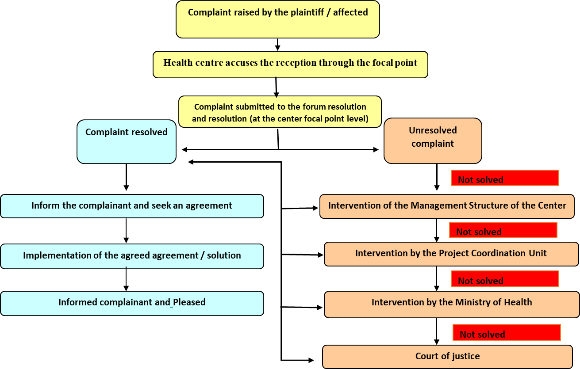

The grievance should be addressed at health center or treatment center, as first line of intervention within 3 days after grievance has been raised. If the grievance is not immediately addressed by the focal point at the treatment centre, the following steps should be followed:
- The management of the Treatment center or project site should intervene and solve the matter within 5 days.
- Project coordination unit (PCU) should intervene if the management of the treatment center can´t solve the issue. This intervention is done through the Social Specialists assistance as a third second level recourse. Finally. The complaint should be settled within 10 working days.
- Should a case not be resolvable internally, it may be referred by the PCU to the Ministry of Health. The complaint should be settled within 20 working days.
- In addition, should either party be dissatisfied, the affected party may bring the complaint to court, where it will be treated in accordance with STP law.

AFAP has already implemented the GRM in line with the commitments of the main project and also of the AF1. A centralized “Record of Complaints” is guaranteed, which will be maintained throughout the life cycle of the project. The complaint records contain: i) the complainant's contact details and information about the complaint itself, ii) the results of the investigations and responses provided, iii) necessary follow-up actions and v) internal communications made in response to the complaints and the result.

7.2 Venues to register Grievances - Uptake Channels
A complaint can be registered directly with COVID-19 (Grievance Redress Committee – GRC) through any of the following modes and, if necessary, anonymously or through third parties.
- By telephone at [toll free to be established],sms and whatsup
- By e-mail to [e-mail address to be activated)
- By letter to the healthcare authorities/GRC
- By letter to contracted NGOs
- By complaint form
- Walk-ins and registering a complaint on grievance logbook at healthcare facility, Vaccination brigade or suggestion box at clinic/hospitals
- By logging the complaint in a website

AFAP has already efectived the following venues:
- E-mail address (mrr_covid19@afap.st)
- Complaint form; distributed and placed in some places and institutions (AFAP reception, S. Tomé campaign hospital, Reference and tuberculosis laboratory)
- In the various contacts, public consultations and field activities of the AFAP safeguards specialist, it has been an opportunity for listening, clarifying and receiving complaints.

Other means and channels for receiving and registering complaints will be implemented according to the project's commitments.

Once a grievance has been received, it should be recorded in the complaints logbook or grievance database. A web based grievance register will be adopted by AFAP for a better follow up and documentation.

7.3 GrievancesRelating to Gender-Based Violence (GBV)
There will be specific procedures in place for addressing GBV, with confidentiality provisions as well as safe and ethical documenting of GBV cases. Multiple channels will be in place for a complainant to lodge a complaint relating to GBV. Specific GRM considerations for addressing GBV under COVID-19 are:

- Establishment of a separate GBV GRM, potentially run by a Service Provider with feedback to the project GRM; operators are to be trained on how to document GBV cases confidentially and empathetically;
- The project is tomake available multiple complaintschannels;
- No identifiable information on the survivor should be stored in the GRM logbook ordatabase.
- The GRM should assist GBV survivors by referring them to GBV Services Provider(s) for support immediately after receiving a complaint directly from a survivor.

The GRM should have in place processes to immediately notify both MOH and the World Bank of any GBV complaints with the consent of the survivor.

7.4 COVID-19 Vaccinationadverse events following immunization
Grievances related to vaccination process will follow the same process as outlined above. However cases Adverse Event Following Immunization (AEFI)management from vaccination program will be managed in accordance with WHOGlobal Manual on Surveillance of Adverse Events . STP established a structure to ensure these events are properly managed as follows:

Health unit team:willhave the following responsibilities (i) Notification of any adverse events that occurred during vaccination against COVID-19 in São Tomé e Principe; (ii) investigate all severe cases observed during covid-19 vaccination; (iii) quickly take control of all serious cases and address them .

If not possible to take control of the situation, the Health unit should immediately refer to the District Level.

Team at district level: - team will consist of district chief physicians, psychologists, and responsible nurses and will have the following tasks: (1) Supervising the investigation, reporting, investigation and management of serious cases that occurred in the health unit level in the district; (ii) Organize the management of information on cases during and after vaccination

If the case is not managed at this level should be immediately referred to Central Level Team

Central level team - the main team will consist of doctors, psychologists, DRs, supervisors, doctors and nurses. The purpose is to help district health teams provide better technical assistance to address cases, reporting, research, and reporting on cases

If the case is not managed at this level should be immediately referred to the National Expert Team Level

National Expert Committee –This team will consist of doctors, psychologists, doctors and nurses from international Organizations such as WHO, UNICEF.
- Create a monitoring system for the measurement, notification of all cases that occur during the 30 days following vaccination.
- Develop a system for collecting information and biological samples to investigate all national committees and three teams are set up with the following tasks
- Help district and referral hospital teams improve reporting and investigation of cases and improve communication
- Report all serious cases
- Organize the management of cases information during and after vaccination

8. MONITORING AND REPORTING

8.1. Involvement of stakeholders in monitoring activities
Monthly reports for SEP implementation, including grievance management, will be prepared and key indicators monitored by the implementation team at the PIU.
Bi-monthly stakeholders’ meetings will be convened to discuss and review key stakeholder engagement indicators. Stakeholders (affected and interested parties) will be given opportunities to indicate whether they are satisfied or not with the project consultation process and what should be changed in the SEP implementation process so as to make it more effective.
The project evaluation (external and internal review) will include aspects of the stakeholder engagement plan (notably key SEP indicators and activities) and recommend improvements.

8.2. Reporting back to stakeholder groups
The SEP will be periodically revised and updated as necessary in the course of project implementation in order to ensure that the information presented herein is consistent and is the most recent, and that the identified methods of engagement remain appropriate and effective in relation to the project context and specific phases of the development. Any major changes to the project related activities and to its schedule will be duly reflected in the SEP. Monthly summaries and internal reports on grievances, enquiries and related incidents, together with the status of implementation of associated corrective/preventative actions will be collated by responsible staff and referred to the senior management of the project. The [monthly] summaries will provide a mechanism for assessing both the number and the nature of complaints and requests for information, along with the Project’s ability to address those in a timely and effective manner. Information on public engagement activities undertaken by the Project during the year may be conveyed to the stakeholders in two possible ways:

- Publication of a standalone biannual report on project’s interaction with the stakeholders.
- A number of Key Performance Indicators (KPIs) will also be monitored by the project on a regular basis

8.3. Monitoringindicators and targets
The indicators to monitor the participation of stakeholders in the Project's activities include:
- Number and percentage of affected households consulted during a planning phase: >60% of key stakeholdersrepresentatives should be consulted.
- Level of participation of affected people in decision making - at least 60 % of their representative to allow that
- Level of understanding of the impacts and mitigation of the project by the parties- >60% should have full understanding
- Effectiveness of local authorities in making decisions about the project - >80% of the decisions should be effective
- Frequency and quality of meetings with those affected - Meetings are to be held before any activities’ initiation, during activities progress (if required) and a feedback session after activities completion;
- Degree of participation of disadvantaged/vulnerable groups in project activities discussions - Ensure all disadvantaged groups are fully consulted
- Number of grievances raised and handled by the project- All grievances lodged should be addressed within the stablished timeframe; % of grievances addressed at first level, % of grievances addressed at 2nd Level and 3rd level; % of grievances taken to court;
- Number of adverse events following immunization– 80% cases addressed at health Centre unit/vaccination point
- Effectiveness of proposed communication strategy against established coverage/targets as indicated in Table 3.
- Feedback to stakeholders – Whenever necessary

.

ANNEX I:PUBLIC CONSULTATION MINUTES

Project: Emergency Project in Response to COVID-19
Objectives:
Disseminate the project to interested and affected parties (PI&A);
Listening to PI&A about the Project and its Environmental and Social Management Framework (ESMF) and collect contributions, suggestions and recommendations to incorporate in the aforementioned documents.
Infrastructure Used
Realization Date: 05/27/2020
Place:
Meeting Room of the Fiduciary Agency for Project Management (AFAP);
Meeting Room of the Ministry of Health of São Tomé and Príncipe and
ZOOM digital platform
Time: 9:00 am to 10:30 am
Was there a photographic record?
(x) No
( )Yes. Insert photo below.
About Content
Proposed Theme / Justification:
Disclosure of the Emergency Project in Response to COVID-19 and its Environmental and Social Management Framework (ESMF).
About the Participants
Estimated Quantity: 50 |  | Accomplished Quantity: 45
- Representatives of the Ministry of Health of São Tomé and Príncipe
- Representatives of the Fiduciary Agency for Project Management (AFAP)
- Representatives of the São Tomé and Príncipe District Chambers
- Representatives of the General Directorate for the Environment of São Tomé and Príncipe
- Representative Ministry of Agriculture
- Representatives of the Blind and partially sighted Association (ACASTEP)
- Representatives of the National Association of Nurse Midwives (ANEP)
- Representatives of the National Union of Nurses and Midwives (SINEP)
- Community members in general
About the Meeting
Main Topics Discussed
The meeting was opened by the AFAP representative, Mr. Adilson Silva, who thanked everyone for their presence, and called for the active participation of everyone for the success of the meeting. After this step, he invited Dr.Cármen Carpio (TTL the project) to make a brief presentation of the project.
Following the meeting, the Consultant (Mr. Custódio Judião), made the presentation of the ESMF which included topics such as: (i) Project Components; (ii) Eligibility criteria for subprojects (iii) Institutional arrangements; (iv) Legal Framework for BM's STP and NASs; (v) Why the ESMF; (vi) Procedures to address the subproject's environmental and social Issues; (vii) Environmental and Social Risks for the Project; (viii) Complaints Management Mechanisms; (ix) Stakeholder and Affected Engagement Plan.
After the presentation, a session of comments, questions and answers was opened, in which the following questions were raised:
Name of Participant | Question / Comment
Mr. Celso Garrido - Ministry of Agriculture: was concerned with the issue of food security for the population, questioning what projects will be carried out in the area of agriculture to guarantee the supply of food goods in São Tomé and Príncipe amid the pandemic. He emphasized that projects of this nature should include the agricultural component that is essential to strengthen immunity.
R.Mr.Adilson –AFAP environmental safeguard specialist- Responded that this project does not include food production/security component, however projects for the agricultural sector have not yet been designed to address to this situation.
Mr. Lourenço Monteiro - General Director for the Environment, questioned what types of projects will be developed and how they can directly benefit ordinary people, since it is extremely important that they have a positive impact on the community in general. He also questioned the criteria for choosing subprojects.
R. Mr. Custódio Judião- the consultant – clarified that this project will benefit to general community due to the nature of the disease. The vulnerable groups will have special attention in this project in a way they will be engaged and communicated about the project, and also ensure that prevention messages and means reach to them. The SEP for this project highlights different types of project stakeholders and presents most suitable engagement methods for each group of stakeholders to ensure they get the most out of the project. As far as subproject selection, the ESMF requires that all subprojects are subject to environmental and social screening before implementation. This process allows identification of E&S risks and development of appropriate E&S management instruments.
Mr. DesidérioPaquete - Responsible for Information and Communication of the Chamber: asked about the final destination of the material (tarpaulins) used in the campaign hospital to respond to the COVID-19 pandemic. He was also concerned about the issue of agricultural surpluses for small farmers who have not found a market in this pandemic moment, suggesting that these products could be used to feed patients.
R. Mr. Custódio- responded that the tarpaulins used as Covid 19 should be disinfected and disposed as contagious material to avoid any future disease spread. About the surplus of the local farmers, Mr. Adilson said that it is something that the Ministry of Health can consider in future as a way of supporting small farmers.
Francisco Norgueira - Secretary-General of ACASTEP: he said that in addition to disinfecting hands and common contact surfaces, a healthy and balanced diet is necessary to prevent COVID-19. He added questioning how people with disabilities can benefit from foodstuffs in this pandemic period, as the movement of people is limited. In this context, he suggested that a project be created to help vulnerable groups in São Tomé and Príncipe.
R. Mr. Adilson responded by saying that the question is very relevant and Government should support people in need. However the project does not include food supply to the vulnerable groups.
Eugénia Neto - President of ACASTEP: she repeated the suggestion of Mr. Francisco Norgueira to develop a project to help people with disabilities, who are mostly citizens without favourable financial conditions to meet basic needs.
Aleixo Rodrigues - District Council of Cantagalo and Doctor: he was concerned about the lack of protective material (masks, gloves, etc.) in hospitals, which leaves health professionals exposed to infection with the new coronavirus and other diseases infectious. The other point raised was the need to strengthen agricultural production and the conservation of locally produced agricultural products.
R. Mr. Adilson responded saying that this is the reason why we need this project to start immediately, because it will finance protective equipment for medical staff.

At the end, the AFAP representative thanked everyone for their presence and participation in the public consultation meeting of the Emergency Project in Response to COVID-19 and mentioned the importance of all parties having participated in the meeting.

ATTENDANCE LIST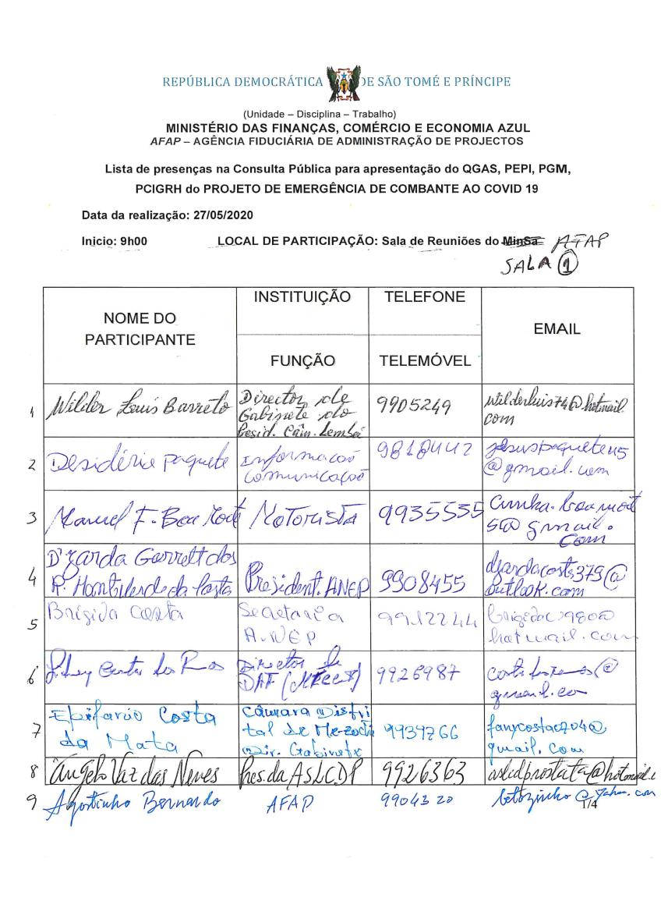
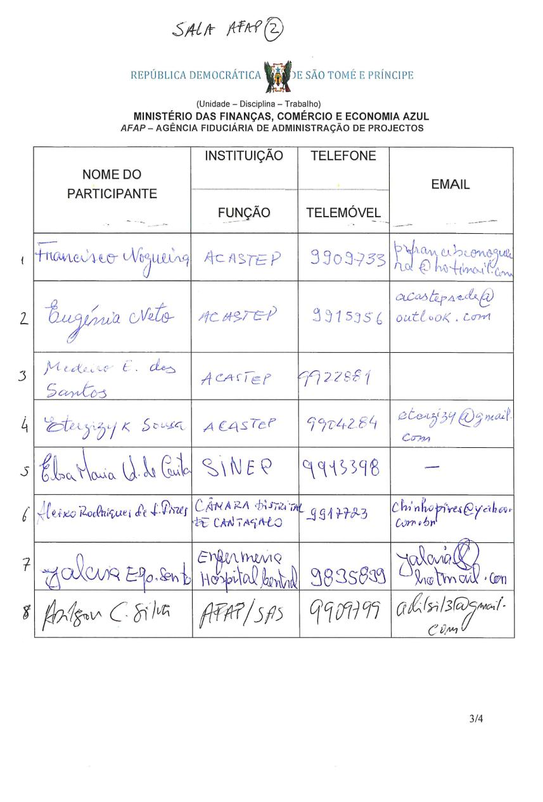
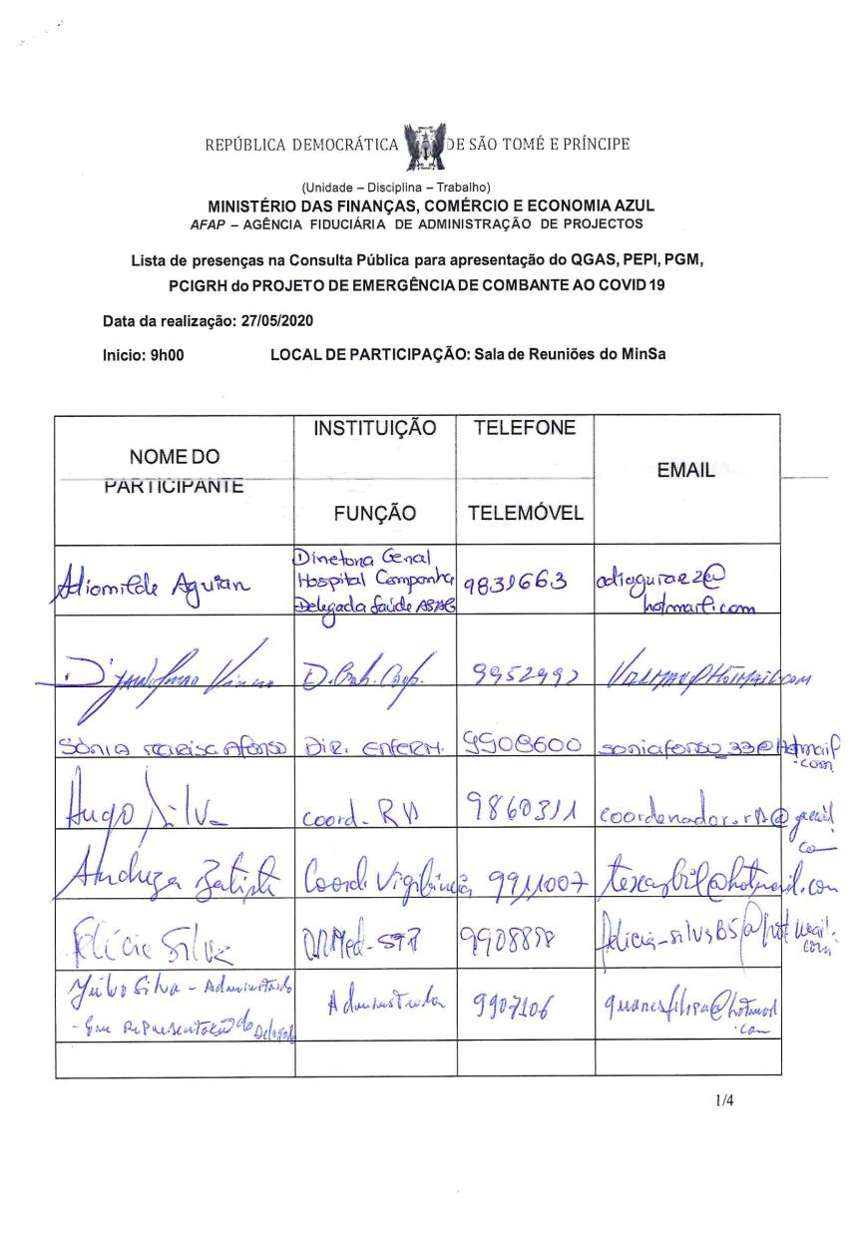
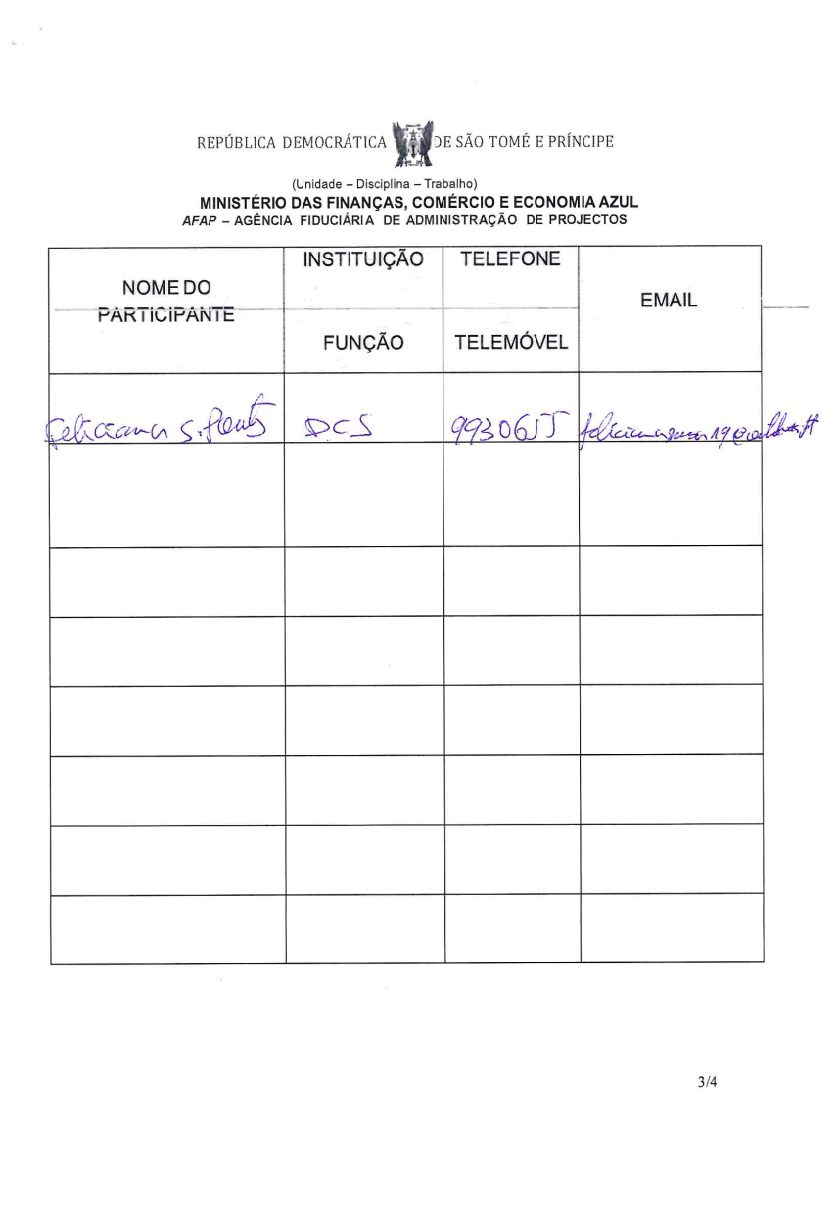
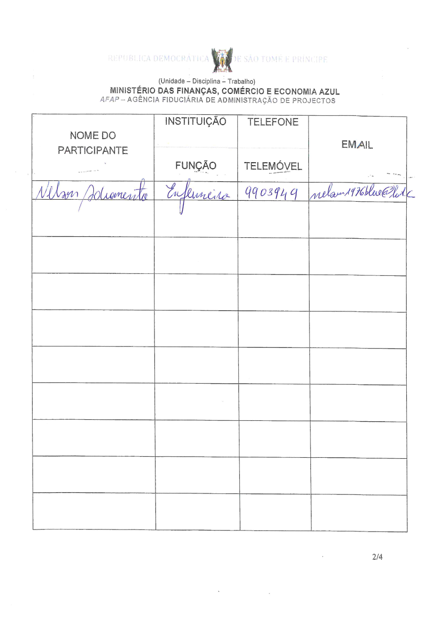

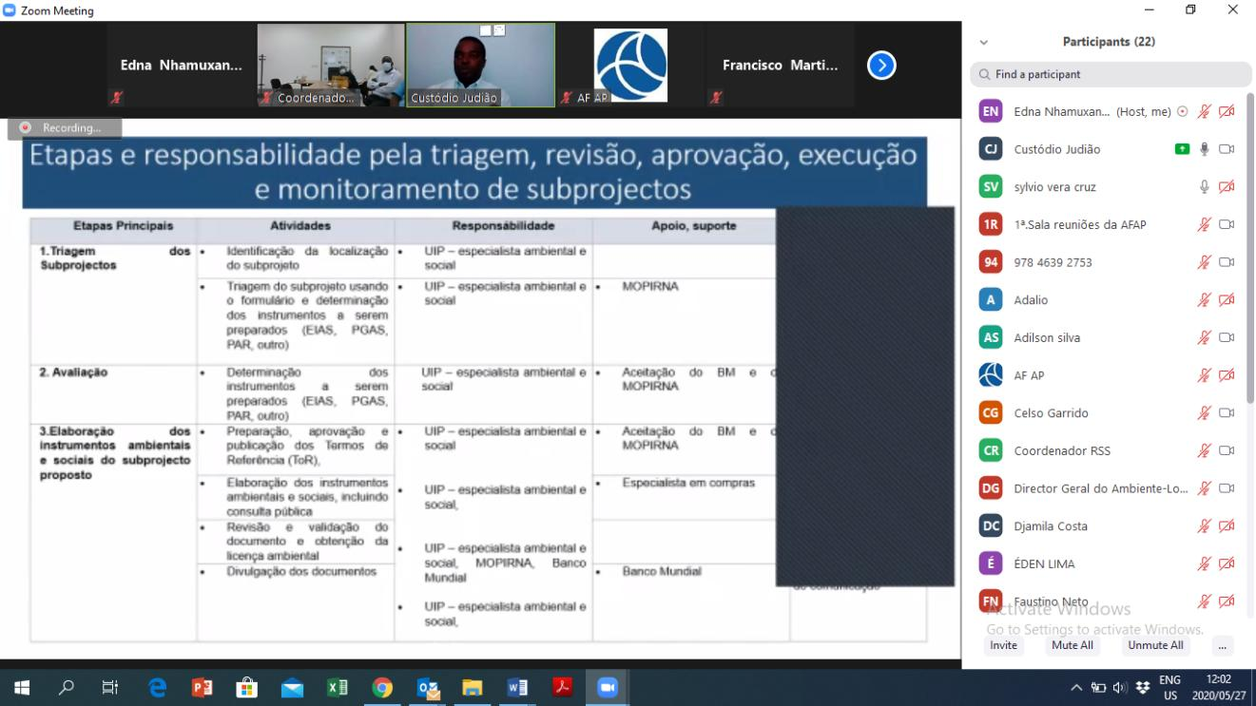
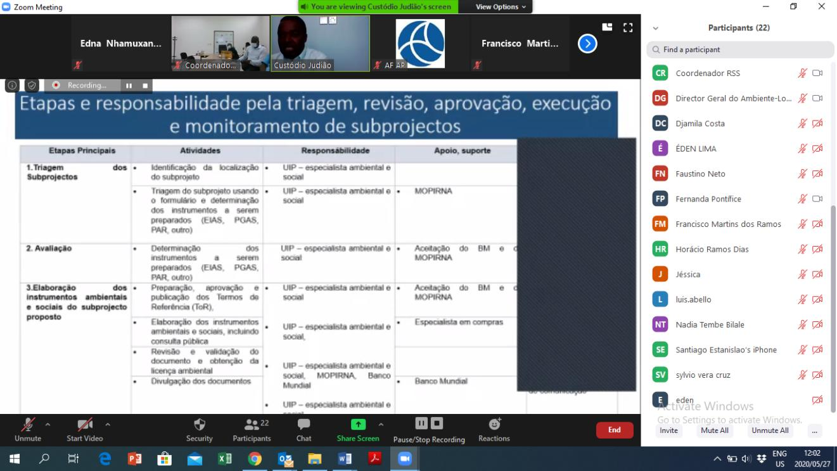
DETAILS ABOUT THE PRESENTATION
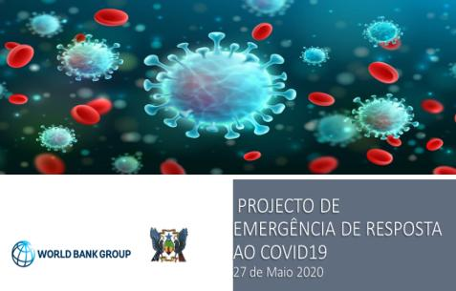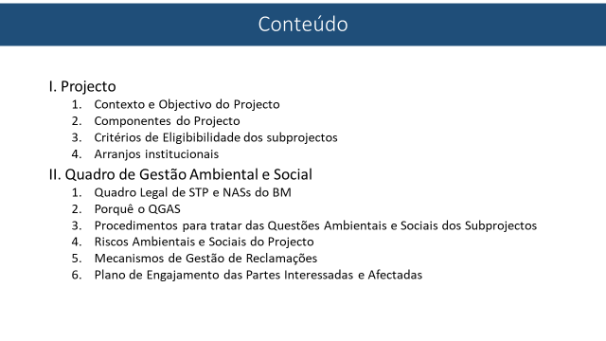
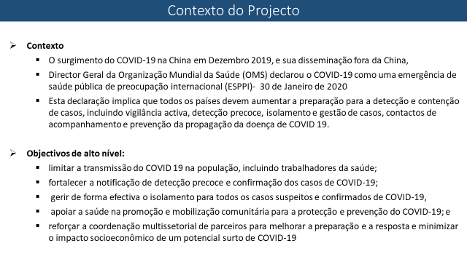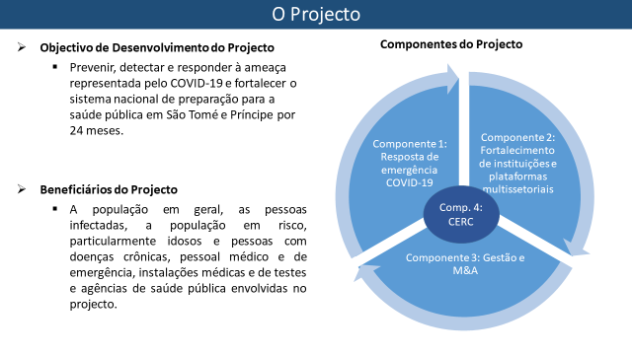
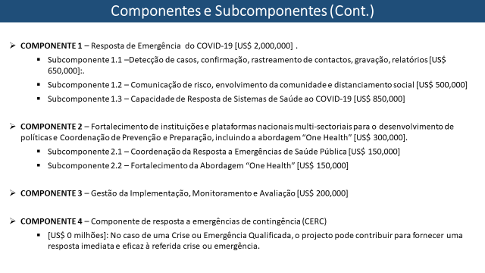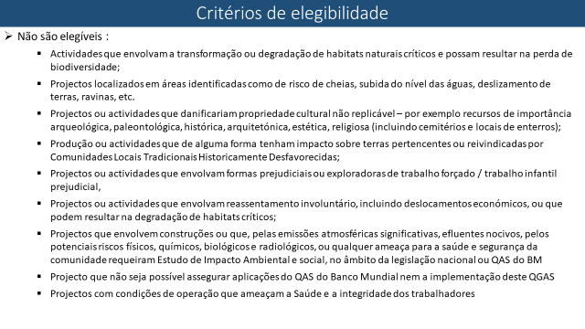

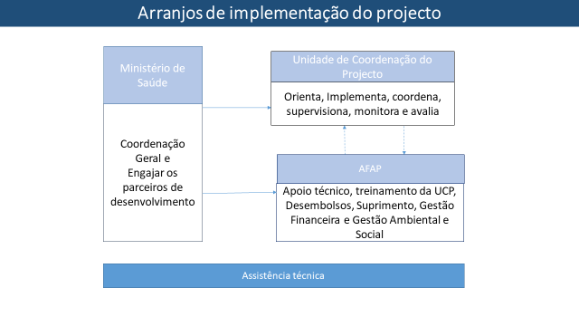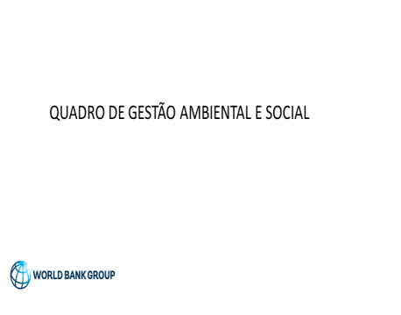

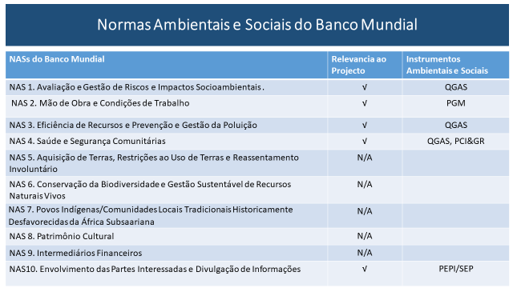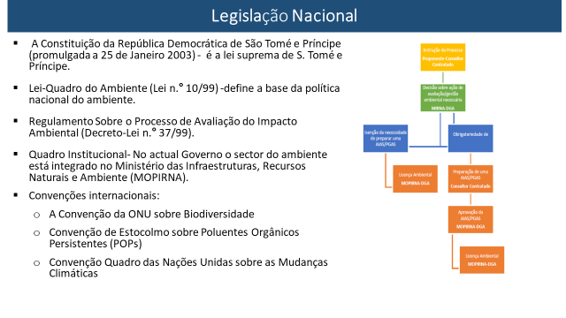

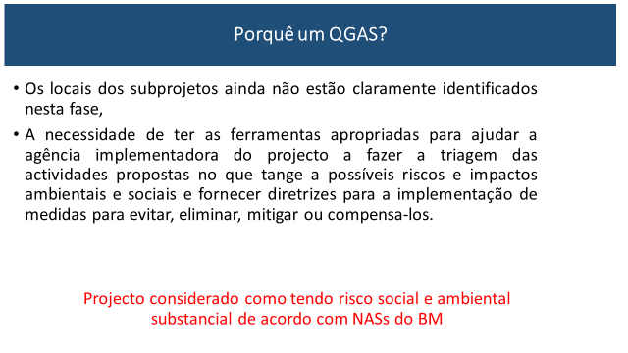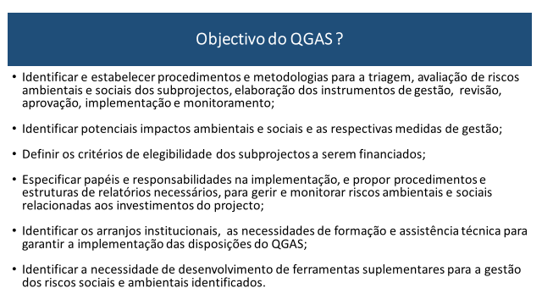

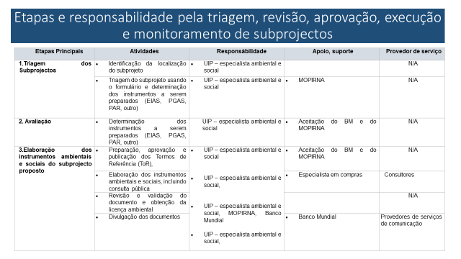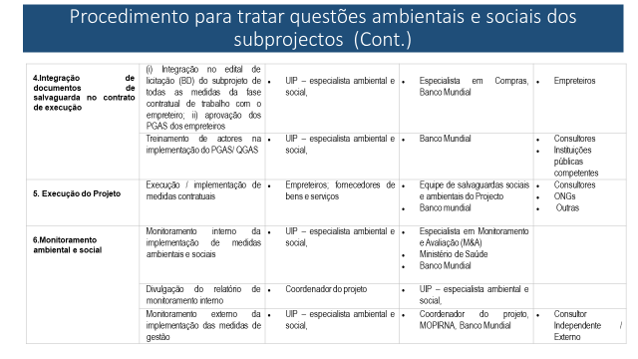

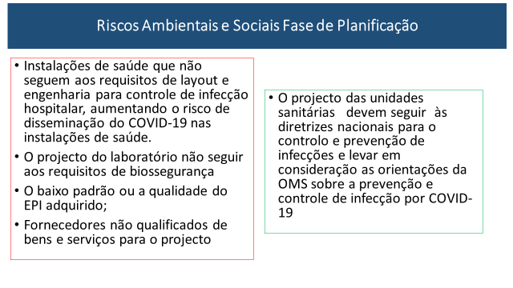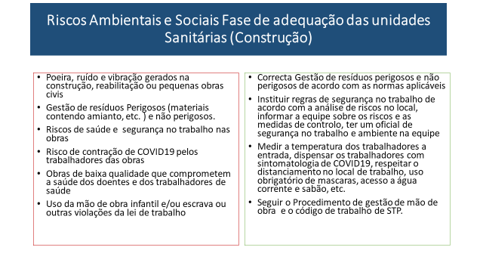

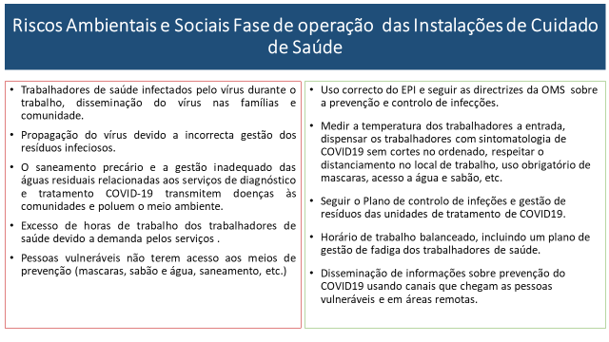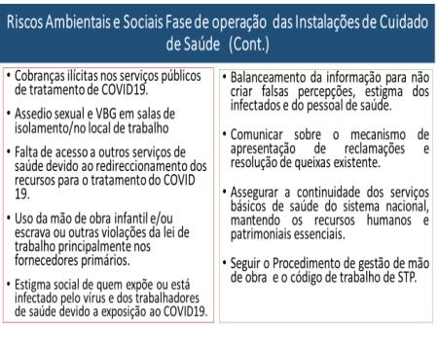

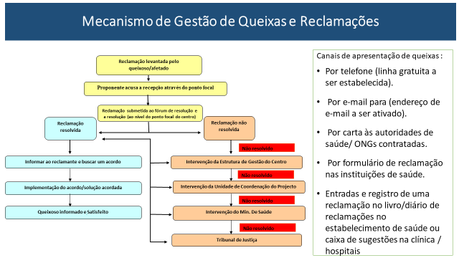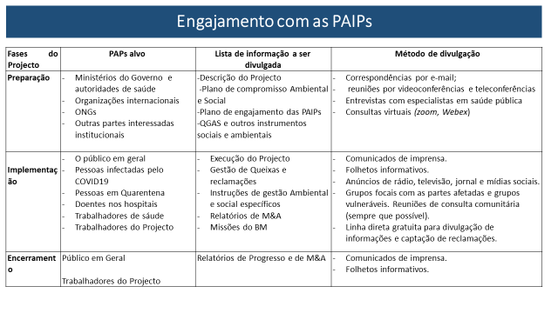

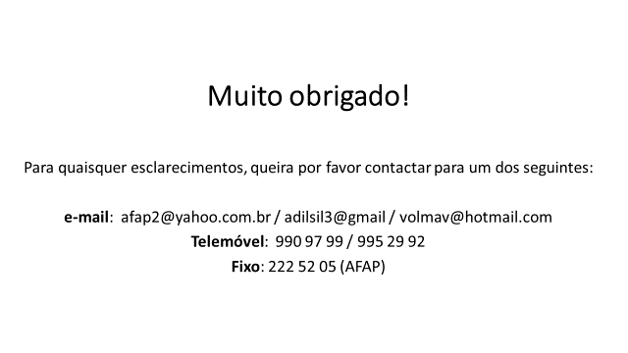

Investing in and building longer-term health emergency preparedness during COVID-19 pandemic: interim guidance for WHO Member States. Geneva: World Health Organization; 2020 (WHO/2019-nCoV/EmergencyPreparedness/Long_term/2020.1)
World Bank, Environmental and Social Framework. Setting Environmental and Social Standards for Investment Project Financing, August 2016.
Vulnerable status may stem from an individual’s or group’s race, national, ethnic or social origin, color, gender, language, religion, political or other opinion, property, age, culture, literacy, illness, physical or mental disability, poverty or economic disadvantage, or dependence on unique natural resources.

