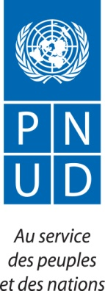

PUBLICATION NOTICE
FOR UNDP SUPPLIERS TO APPROPRIATE ITS NEW PROCUREMENT PLATFORM

In April 2022, the United Nations Development Programme (UNDP) launched an operation to update supplier profiles, accompanied by training sessions on the appropriation of its procurement management platform, Quantum.
As part of its efforts to strengthen the capacities of local service providers and encourage their active participation in tenders, UNDP is organizing training sessions for private sector operators. These training sessions focus on the use of the Quantum platform and the technical and administrative skills required to access business opportunities in São Tomé.
To this end, UNDP invites all suppliers of goods, works and/or services operating in São Tomé to come to its premises to register and benefit from the training sessions scheduled for Friday, March 6th in São Tomé, according to the schedule below:
HOURLY

FRIDAY, March 6, 2026: From 9:45 AM to 12 PM

Suppliers who are unable to attend the training in person may access the session through the link provided below:

Microsoft Teams meeting
Join: https://teams.microsoft.com/meet/32480431895856?p=r8BUpMIPBLodTkwRHV
Meeting ID: 324 804 318 958 56
Passcode: cf3aa6wW

IMPORTANT INFORMATION

- The maximum number of participants per company is two (02) people.
- You must bring a laptop and an internet connection.

For further information, please contact the following email address: SAO TOME OFFICE : procurement.st@undp.org

Best regards.

